Daniel Morris
ddm855
11188831

Table Names:

Works: The artwork in the museum is called works.
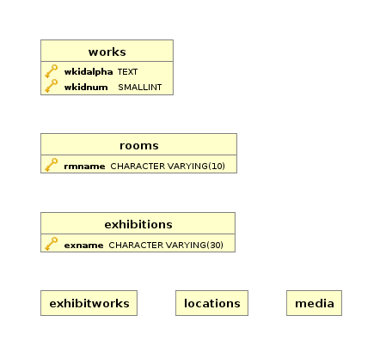
Media: This table mainly contains the media the artist used
Rooms: This table consists of room attributes
Exhibitions: This table consists of general attributes of an exhibit
ExhibitWorks: This table consists of the works attributed with an Exhibit
Locations: This table consists of all the locations of all the works in the museum

Attribute Names:

Work Table Attributes:
- all attributes start with “wk” to symbolize work
- two of the attributes have “Id” in them to symbolize identification purposes
- the rest are just short forms of the actual meaning of the attributes
Media Attributes:
-all start with “med” to symbolize media
- two of the attributes have “Id” in them to symbolize identification purposes
Rooms Attributes:
- all start with “rm” to symbolize room
- the rest are just short forms of the actual meaning of the attributes
Exhibition Attributes:
- all start with “ex” to symbolize exhibition
- the rest are just short forms of the actual meaning of the attributes
ExhibitWorks Attributes:
- all start with “ew” to symbolize exhibition works
- the rest are just short forms of the actual meaning of the attributes
Locations Attributes:
- all start with “loc” to symbolize location
- two of the attributes have “Id” in them to symbolize identification purposes
- the rest are just short forms of the actual meaning of the attributes

View Names:

HeadAllWorks: Since the HEAD of the museum wants to see ALL of the WORKS I thought this would be an appropriate name
PublicAllExhibitions: Since the PUBLIC would like to see ALL of the EXHIBITIONS I thought this would be an appropriate name
PublicExhibitionWorks: Since the PUBLIC would like to see all of the WORKS in an EXHIBITION I thought this would be an appropriate name
CuratorNextAvailableWorks: Since the CURATOR would like to see the NEXT WORKS that are AVAILABLE I thought this would ne an appropriate name
CuratorUnusedSpaceInGalleries: Since the CURATOR would like to see how much UNUSED SPACE is IN the GALLERIES I thought this would be an appropriate name
Data Types
I tried to keep my data types as small as possible but still allowing a little room for growth. I used small ints on all the small numbers in the system. I used varchar for all the text attributes with enough characters to fit every attribute plus a little extra. I used the date datatype for all dates.

Data Obtained

I obtained almost all my data through https://www.mca.com.au/collection/all/.
The exact month and day of completion were not provided by all attributes so I computed those randomly and the dates of acquisition were sometimes given but if not I also computed those randomly. I distinguished the type and sub-type by my own judgment on the picture of the work.

